**DAILY ONLINE ACTIVITIES SUMMARY**

|  |  |  |  |  |  |
| --- | --- | --- | --- | --- | --- |
| **Date:** | | **18/06/2020** | **Name:** | **JASLINE SHARON TAURO** | |
| **Sem & Sec** | | **4th sem, A Section** | **USN:** | **4AL18CS029** | |
| **Online Test Summary** | | | | | |
| **Subject** | **---** | | | | |
| **Max. Marks** | **---** | | **Score** | **---** | |
| **Certification Course Summary** | | | | | |
| **Course** | | Application Developer | | | |
| **Certificate Provider** | | **AWS Educate** | **Duration** | | **3 hrs.** |
| **Coding Challenges** | | | | | |
| **Problem Statement:**  Find the smallest positive integer value that cannot be represented as sum of any subset of a given array sorted in ascending order. | | | | | |
| **Status: EXECUTED** | | | | | |
| **Uploaded the report in GitHub** | | | **YES** | | |
| **If yes Repository name** | | | <https://github.com/jaslinesharontauro/JAVA_Prgms> | | |
| **Uploaded the report in slack** | | | **YES** | | |

Online Test Details: (Attach the snapshot and briefly write the report for the same)

Certification Course Details: (Attach the snapshot and briefly write the report for the same)

Coding Challenges Details: (Attach the snapshot and briefly write the report for the same)

CERTIFICATION COURSE DETAILS:

Today I have continued the course “Application Developer” by AWS Educate. In this course today I learnt about ‘Platforms’. In this module I learnt about platforms in general and in operating systems and also about platform Virtualization. I have also completed this module by clearing the assessment.





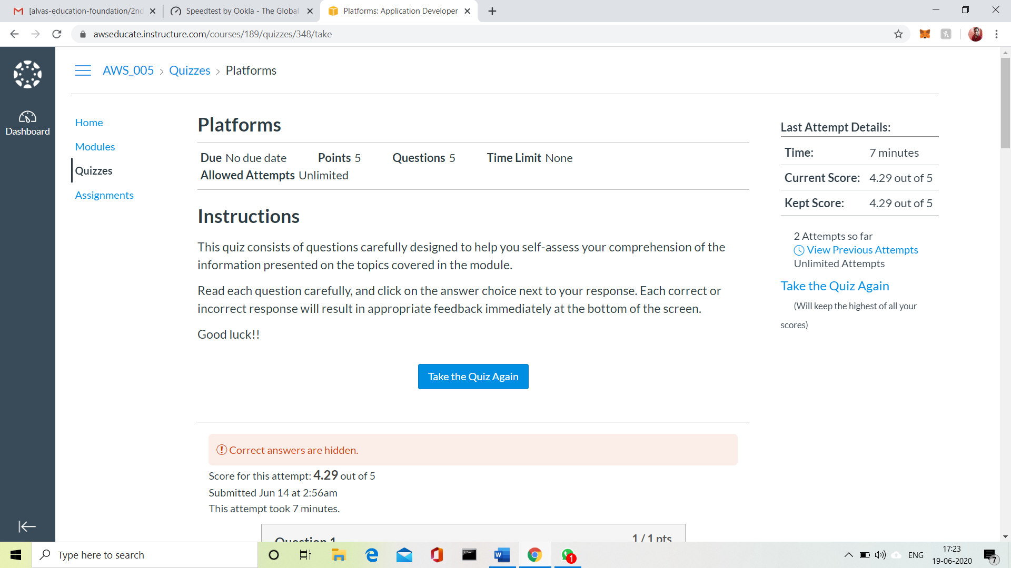

3.CODING CHALLENGES:

Problem Statement:

Find the smallest positive integer value that cannot be represented as sum of any subset of a given array sorted in ascending order.

Given a sorted array (sorted in non-decreasing order) of positive numbers, find the smallest positive integer value that cannot be represented as sum of elements of any subset of given set  
Examples:

Input: arr [] = {1, 3, 6, 10, 11, 15};  
Output: 2  
There are no one or more elements to be added up to get sum = 2

Input: arr [] = {1, 1, 1, 1};  
Output: 5  
1 = 1, 1+1 = 2, 1+ 1 + 1 = 3, 1 + 1 + 1 + 1 = 4,  
There is no elements in the array to get sum 5

Input: arr[] = {1, 1, 3, 4};  
Output: 10  
1 = 1, 1 + 1 = 2, 3 = 3, 1 + 3 = 4, 1 + 4 = 5, 1 + 1 +4 = 6, 3 + 4 = 7........  
To get sum 10, there is no elements in the array.

Input: arr[] = {1, 2, 5, 10, 20, 40}  
Output: 4  
There are no elements to get sum = 4.

Input: arr [] = {1, 2, 3, 4, 5, 6}  
Output: 22

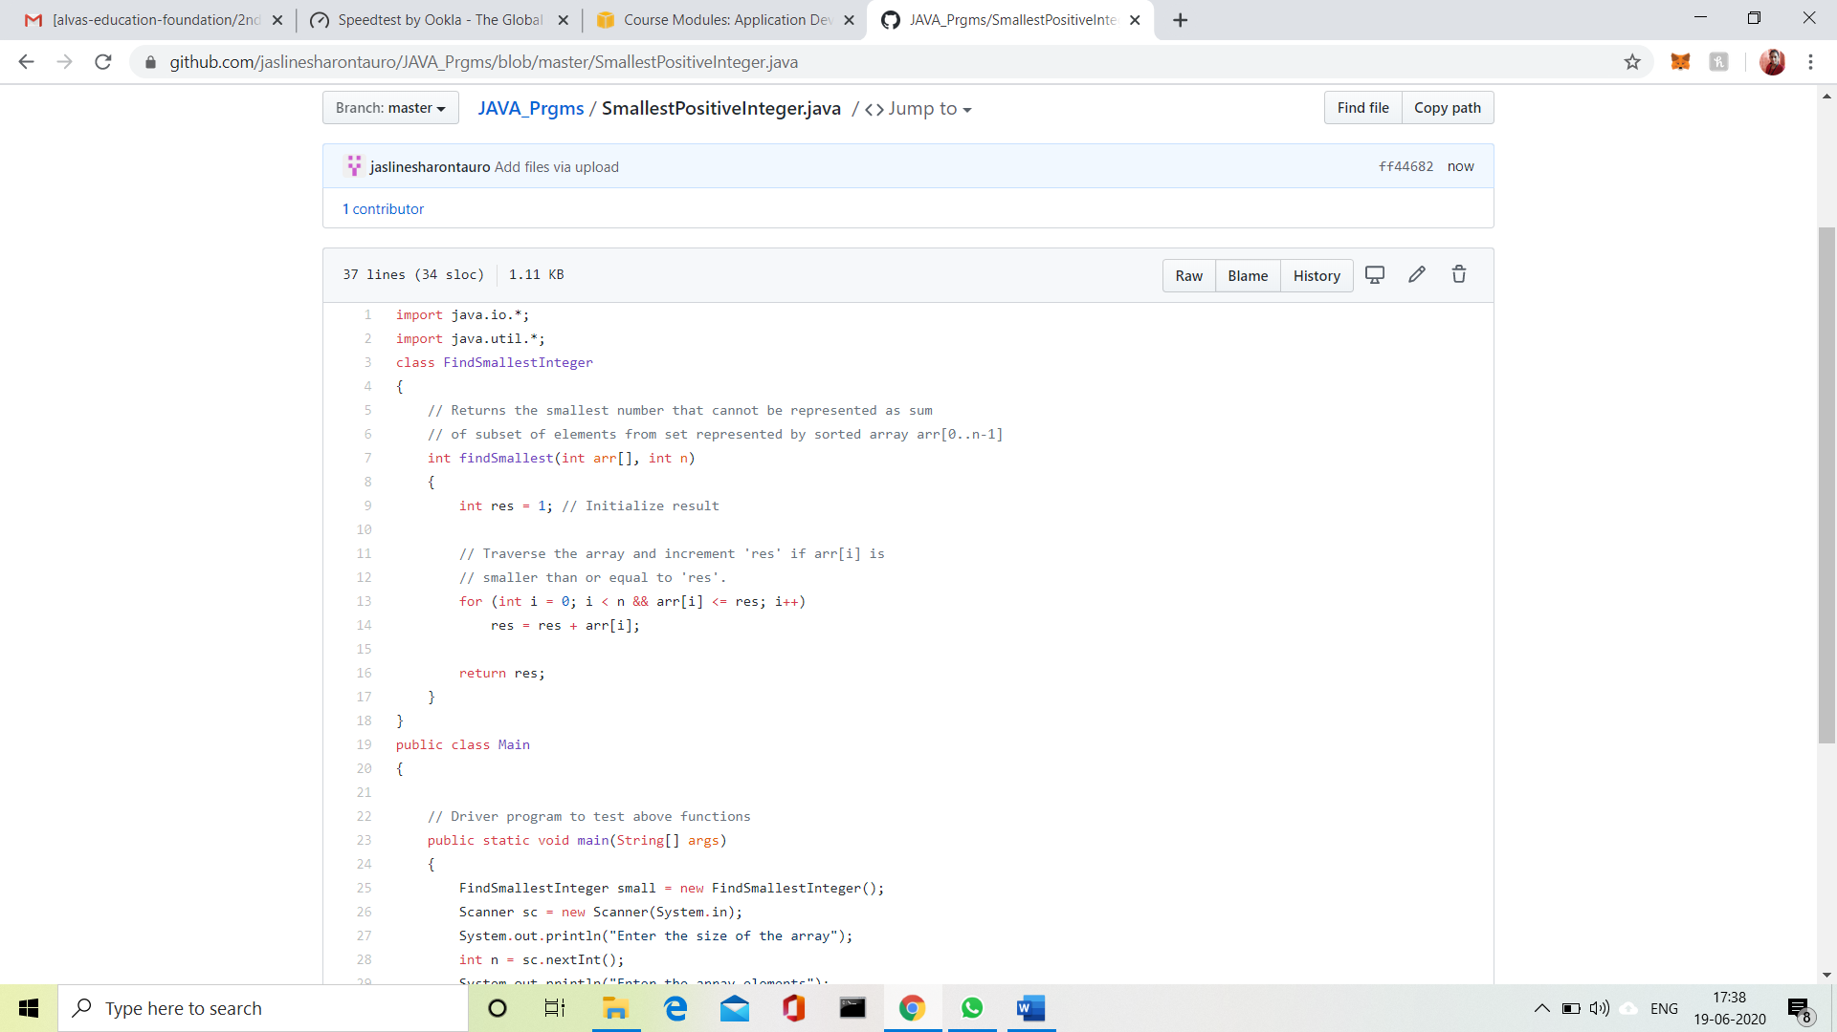

Solution uploaded in GitHub.